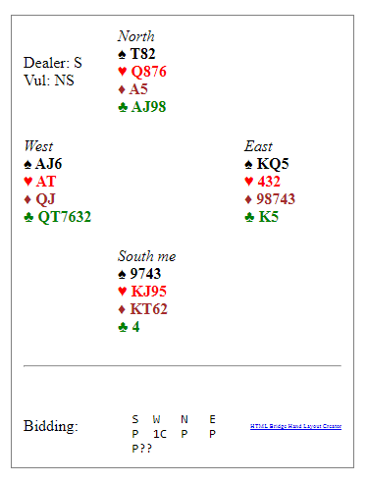
Should I bid? Hand 15 on Wednesday night 27th January.
The bidding went: Pass from me, 1 Club from West, Pass Pass, ??? Should I bid?
1 Club made exactly = 70.
The fact that everyone else was either in 2 Clubs going 1 light, or N/S made 2 or 3 Hearts, giving us a completely bottom board is not the point. After all, sometimes bad things happen.
My points are twofold. Firstly one should always bid with 6 points in case partner has a maximum hand, and you might miss game.
Secondly, If partner opens a suit, (not 1NT), they always promise another bid, unless you make a limit bid.

Digressing, 3 times that night the opponents made a Take Out double, holding minimum points, BUT 5 or more cards in the suit just opened. PASS is allowed, honestly. (That double, for penalties, went out about 80 years ago).

